**REPORT TEMPLATE**

**1.INTRODUCTION**

**1.1 OVERVIEW**

Crm application for schools/colleges is made a close relationship b/w students & school.through this ,parent can know about kids. student can know their grades & exams. Teacher can easily report to parents etc. it’s a powerful and should be a successful platform for everyone. Here we come to know everything about school programs, function, year calander ,exams, etc.

**1.2 PURPOSE**

The main purpose of the application is to make a clear and good communication with school management .this helps as short distance relationship, whenever or 24 x 7 we can communicate with each other. Due to this we can easily communicate without travelling to the places.

**2.PROBLEM DEFINITION AND DESIGN THINKING**

**2.1 EMPATHY MAP**

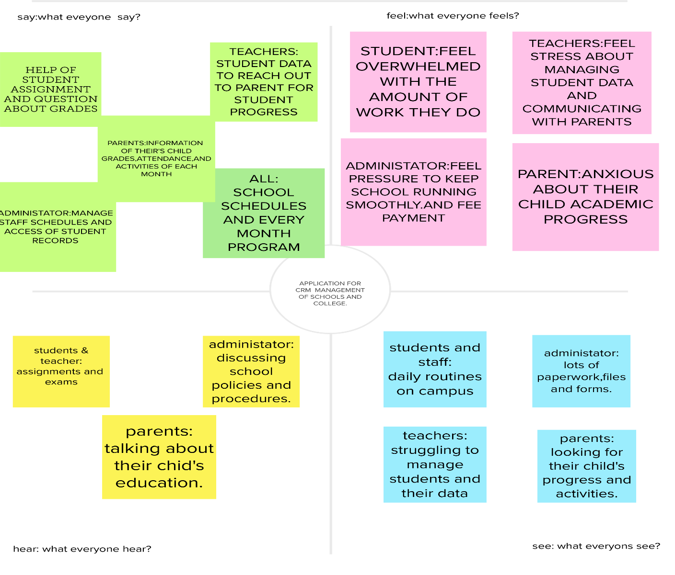

**2.2 BRAINSTROMING & IDEAS POLARISATION**

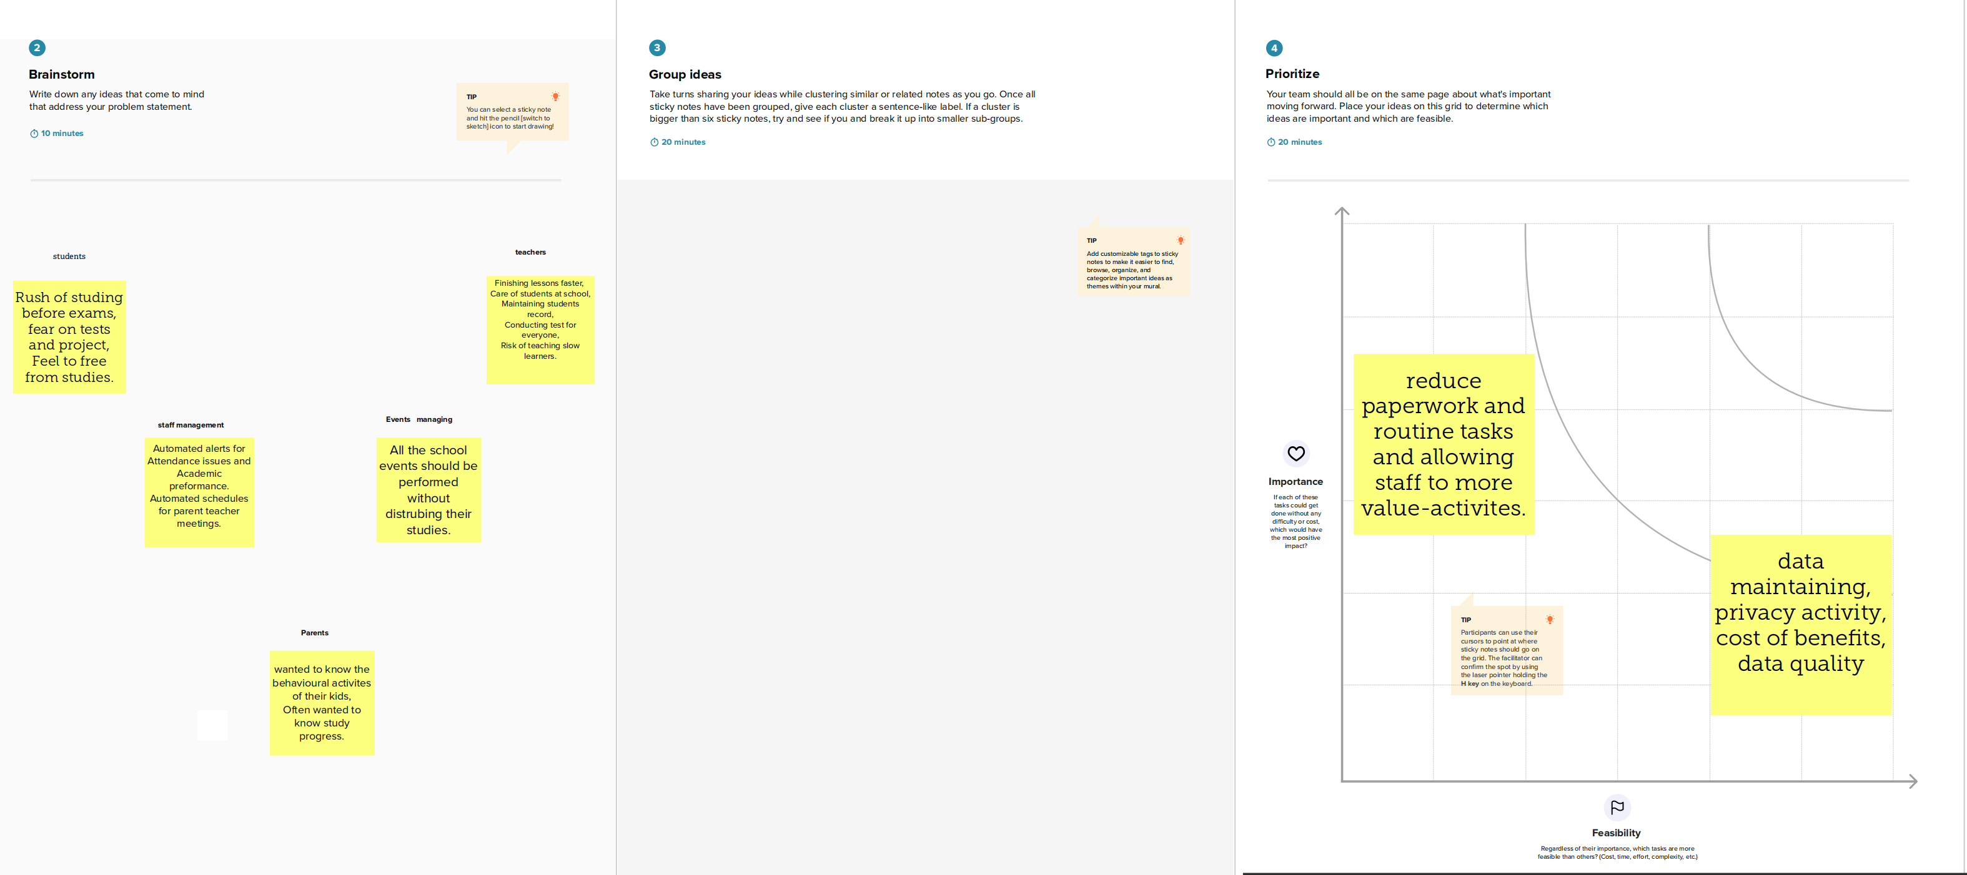

**3.RESULT**

**3.1 DATA MODEL**

|  |  |
| --- | --- |
| **OBJECT** | **FIELD** |
| **SCHOOL** | |  |  | | --- | --- | | **SCHOOL NAME** | **TEXT** | | **E-MAIL** | **MAIL** | | **SCHOOL FEES TABLE** | **FEES** | | **SCHOOL WEBSITES** | **URL** | |  |  | |
| **STUDENT/PARENT** | |  |  | | --- | --- | | **NAME,ADRESS,CLASS** | **TEXT** | | **GENDER,QUERY** | **TEXT** | | **ROLL NO,MARKS** | **NUMBER** | | **RESULT** | **PICKLIST** | | **SCHOOL** | **MASTER DETAIL RELATIONSHIP** | |
| **TEACHER** | |  |  | | --- | --- | | **DETAILS** | **TEXT** | | **NUMBER** | **PHONE** | | **E-MAIL** | **MAIL** | | **SUB,STUDIES** | **TEXT** | |  |  | |

**3.2 SAMPLE ACTIVITY SCREENSHOT**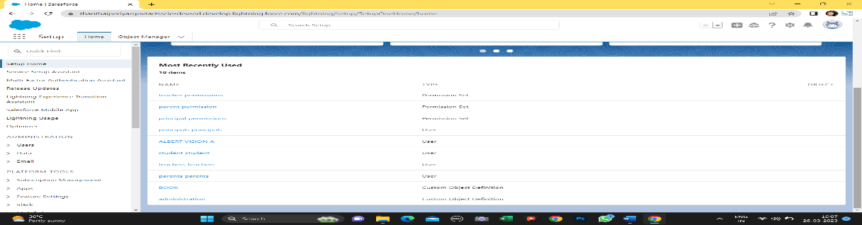

**4.TRAILHEAD PROFILE PUBLIC URL**

**TRAM LEADER :** [**https://trailblazer.me/id/albertvision210**](https://trailblazer.me/id/albertvision210)

**TEAM MEMBER 1 :**  [**https://trailblazer.me/id/anbua8**](https://trailblazer.me/id/anbua8)

**TEAM MEMBER 2 :** [**https://trailblazer.me/id/aalagu2**](https://trailblazer.me/id/aalagu2)

**TEAM MEMBER 3 :** [**https://trailblazer.me/id/akumar8292**](https://trailblazer.me/id/akumar8292)

**5.ADVANTAGES & DISADVANTAGES**

**ADVANTAGES**

1. Improved communication: CRM applications can help schools and colleges communicate more effectively with students, parents, and other stakeholders. By keeping all communication in one place, it becomes easier to track and manage.
2. Personalized experience: CRM applications can help schools and colleges provide a more personalized experience for students and parents. By tracking interactions and preferences, schools can tailor their communication and support to meet the unique needs of each individual.
3. Better organization: With a CRM application, schools and colleges can keep all their data and records in one place, making it easier to access and analyze. This can lead to better decision-making and more efficient operations.
4. Enhanced student experience: CRM applications can help schools and colleges provide a better overall experience for students, from the initial enrollment process to ongoing support and engagement.

**DISADVANTAGES**

1. Cost: CRM applications can be expensive, and schools and colleges may not have the budget to invest in this technology. Additionally, there may be ongoing costs associated with maintaining and updating the software.
2. Complexity: CRM applications can be complex and require specialized knowledge to set up and use effectively. Schools and colleges may need to invest in training and support to ensure that staff members can use the application correctly.
3. Privacy concerns: With any system that collects personal data, there are always privacy concerns. Schools and colleges need to be careful to protect student and parent data and ensure that it is used only for appropriate purposes.
4. Resistance to change: Implementing a CRM application can be a significant change for staff members, and some may be resistant to the new technology. It may take time and effort to get everyone on board and using the application effectively.

**6.APPLICATION**

CRM applications can be used by schools and colleges to improve communication, personalize the student experience, better organize data and records, and enhance overall operations. These applications can help schools and colleges provide a better experience for students and parents, leading to greater satisfaction and engagement.

However, schools and colleges need to be mindful of the potential drawbacks of CRM applications, including cost, complexity, privacy concerns, and resistance to change. It is important to carefully evaluate the benefits and costs of using a CRM application before making a decision.

**7.CONCLUSION**

CRM applications can be a useful tool for schools and colleges, allowing them to better manage relationships with students, parents, and other stakeholders. However, there are also potential drawbacks to consider, and careful evaluation and planning are necessary to ensure that the application is used effectively and efficiently. By carefully weighing the benefits and costs, schools and colleges can make informed decisions about whether to implement a CRM application and how to use it to support their goals and objectives.